Contents

**Guru Nanak Gurpurab: Honoring the First Sikh Guru** 1

**Introduction** 1

**Historical Background** 1

**The Birth of Guru Nanak Dev Ji** 1

**Establishment of Sikhism** 1

**Celebrations of Gurpurab** 1

**Main Traditions and Practices** 2

**Conclusion** 2

**References** 2

**Guru Nanak Gurpurab: Honoring the First Sikh Guru**

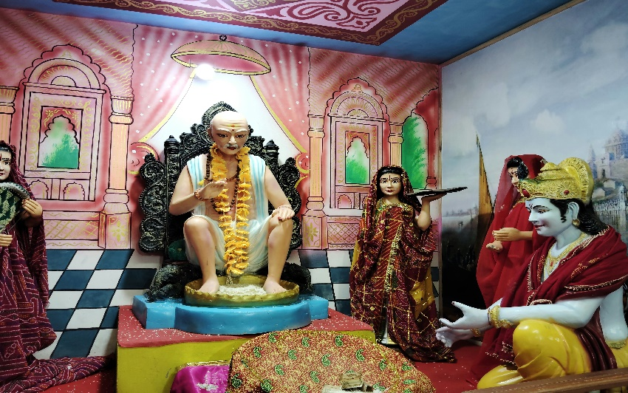**Introduction**

Guru Nanak Gurpurab, also known as **Guru Nanak Jayanti**, is one of the most sacred festivals in Sikhism. It marks the birth anniversary of **Guru Nanak Dev Ji**, the founder of the Sikh religion and the first of the ten Sikh Gurus. Celebrated with great devotion and enthusiasm across India and around the world, the festival reflects Guru Nanak’s timeless teachings of **oneness of God, equality, humility, and service**.

**Historical Background**

**The Birth of Guru Nanak Dev Ji**

Guru Nanak Dev Ji was born in **1469** in **Rai Bhoi Ki Talwandi**, now known as **Nankana Sahib**, located in present-day Pakistan. From a young age, he showed signs of spiritual wisdom and questioned religious rituals and social divisions. Guru Nanak's message emphasized **universal brotherhood, devotion to one God**, and living a life of truth and compassion.

He traveled extensively across Asia, the Middle East, and India on spiritual missions known as **Udasis**, spreading his message of peace, love, and unity among Hindus, Muslims, and people of other faiths. His teachings laid the foundation of **Sikhism**, which was later developed by the nine successive Gurus.

**Establishment of Sikhism**

Guru Nanak taught the importance of **Naam Japna** (remembering God), **Kirat Karni** (honest living), and **Vand Chakna** (sharing with others). He rejected caste distinctions, idol worship, and ritualism, promoting instead a life guided by simplicity, humility, and service. His compositions were compiled in the **Guru Granth Sahib**, the holy scripture of Sikhs.

**Celebrations of Gurpurab**

Guru Nanak Gurpurab usually falls in **October or November**, on **Kartik Purnima** (the full moon of the month of Kartik, according to the lunar calendar). The celebration begins two days prior with a continuous **Akhand Path** (non-stop reading of the Guru Granth Sahib) in Gurdwaras.

**Main Traditions and Practices**

* **Nagar Kirtan**: A religious procession led by the **Panj Pyare** (Five Beloved Ones), featuring singing of hymns, martial arts demonstrations, and community participation.
* 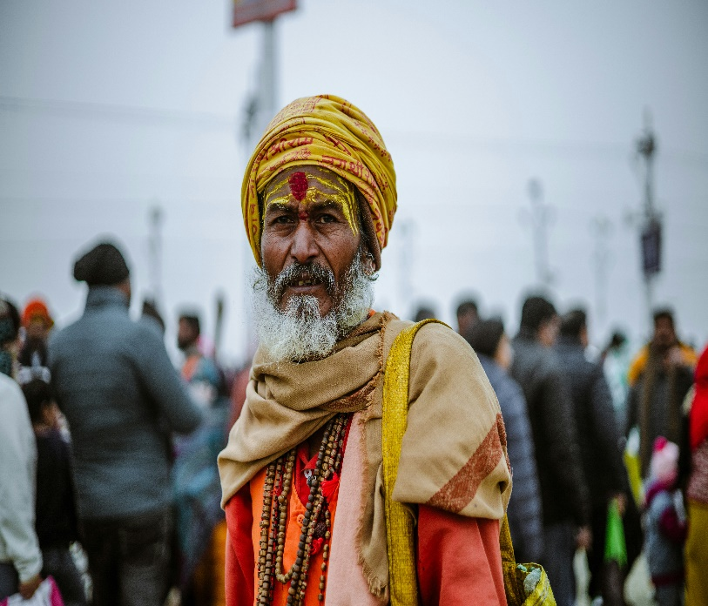**Prabhat Pheris**: Early morning processions through local streets with devotees singing devotional songs.
* **Langar (Community Kitchen)**: A key feature of Gurpurab, where free meals are served to all, symbolizing equality and community service.
* **Kirtan and Discourses**: Special congregations are held where hymns (Shabads) from the Guru Granth Sahib are sung, and the life and teachings of Guru Nanak Dev Ji are discussed.

Celebrations are held not only in India but across the Sikh diaspora in countries like Canada, the UK, the USA, Malaysia, and Australia.

**Conclusion**

Guru Nanak Gurpurab is more than a religious festival—it is a reminder of the **universal values of love, equality, humility, and service**. Guru Nanak Dev Ji’s teachings remain profoundly relevant today in a world often divided by race, religion, and politics. By following his principles, individuals can strive toward a more compassionate and just society.

**References**

1. Singh, Khushwant. *A History of the Sikhs*, Volume 1. Oxford University Press, 2004.
2. McLeod, W.H. *Guru Nanak and the Sikh Religion*. Oxford University Press, 1968.
3. BBC Religions. “Guru Nanak Gurpurab.”